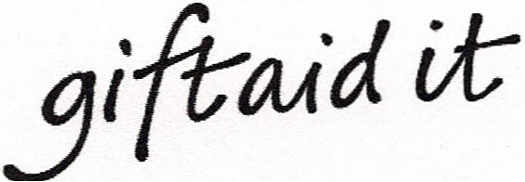
Gift Aid declaration Ref No:
Name of charity Norfolk Fire Museum
Please treat the enclosed gift of £ as a Gift Aid donation and for all future donations.
I confirm I have paid or will pay an amount of Income Tax and / or Capital
Gains Tax for the current tax year (6 April to 5 April) that is at least equal to
the amount of tax that Norfolk Fire Museum I donate to, will reclaim on my gifts for the current and future tax years. I understand that other taxes such as VAT and Council Tax do not qualify. I understand Norfolk Fire Museum will reclaim 25p of tax on every £1 that I have given.
Donor's details
Title First name or Initials.
Surname

Full Home address

Postcode

Signature
Date
Please notify the charity if you :-
- Want to cancel this declaration
- Change your name or home address
- No longer pay sufficient tax on your income and/or capital gains.
If you pay Income Tax at the higher or additional rate and want to receive the additional tax
relief due to you, you must include all your Gift Aid donations on your Self-Assessment tax
return or ask HM Revenue and Customs to adjust your tax code.

Registered Charity 1181921

Once completed please return this form to the treasurer at 21 Chapel Lane, Coltishall, Norwich, NR12 7DR. Cheques should be made out to “Norfolk Fire Museum”.

